[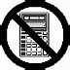](https://www.bing.com/images/search?q=non+calculator+sign&view=detailv2&&id=043E13813D6D05CEC867949DAA29599DFE25EA7A&selectedIndex=2&ccid=b3Tc62fU&simid=608020899046754781&thid=OIP.M6f74dceb67d4b1d1afe73d5574f3c017o0)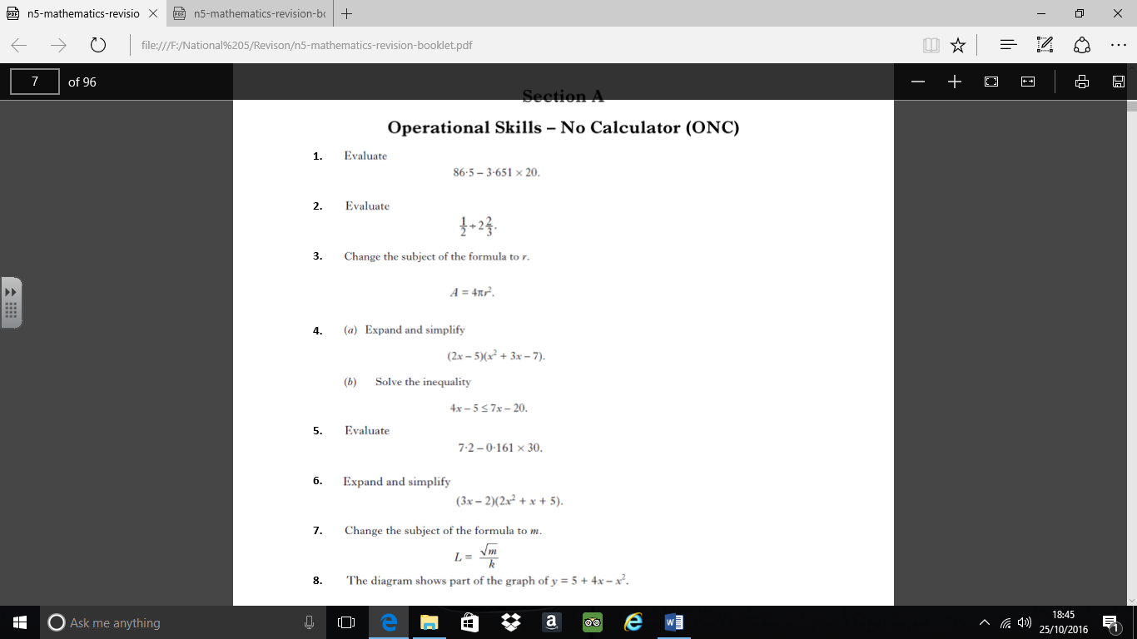National 5: Mixed Exam Questions 1

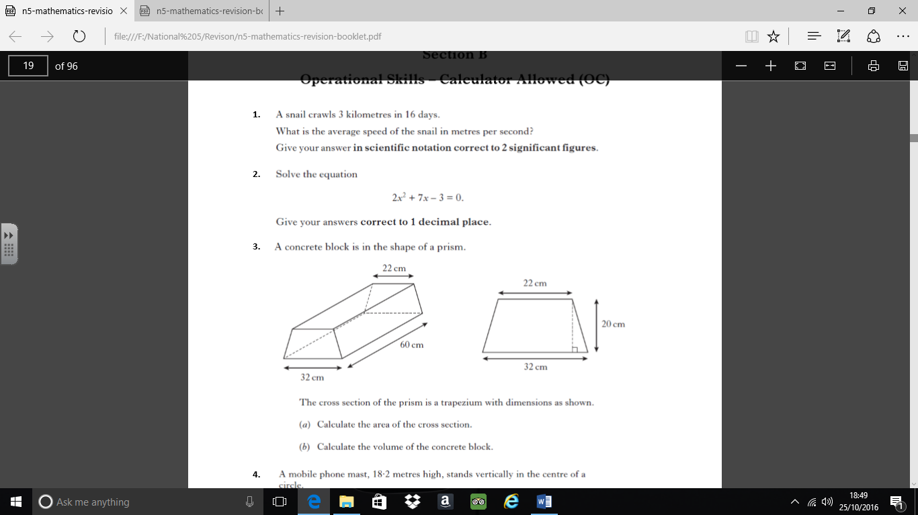

5.

6.

7.