**Mathematics Department**

**National 4**

**Added Value Unit Revision**

**1**. ***Littletrees*** department store is offering discounts of 30% to customers who take a store card. Calculate the cost of items which cost the following amounts before discount:

**(a)** £50 **(b)** £100 **(c)** £25 **(d)** £30

**(e)** £95 **(f)** £10 **(g)** £200 **(h)** £150

**2**. ***CutscoCash’n’Carry*** charge VAT at the rate of 20%. Calculate the cost including VAT on the following goods :

**(a)** £100 **(b)** £30 **(c)** £50 **(d)** £70

**(e)** £250 **(f)** £180 **(g)** £90 **(h)** £400

**3.** A packet of crisps weighs 30g. Special offer packs give 40% extra free. What weight of crisps do you get in a packet now?

**4.** Calculate:

**(a)**  of £96 **(b)**  of 65kg **(c)**  of £36.40

**(d)**  of 48cm **(e)**  of £136 **(f)**  of 58·4g

**5.**  of the cars in a car park were grey. If there were 560 cars altogether, how many of them were grey?

**6**. Diane does a lot of travelling in her job. She keeps a note of the miles she drove each week for the first 10 weeks.

785 846 816 704 685 723 960 788 729 814

Calculate the mean weekly mileage.

**7.** The first eight customers at a supermarket one Saturday spent the following amounts:

£25.10, £3.80, £20.50, £15.70, £38.40, £9.60, £46.20, £10.46.

**(a)** Find the mean amount spent.

**(b)** I spend £11.53. Compare this to the average amount spent.

**8**. The ***Lucky Strike Match Company*** advertises the *average* contents of its boxes as 48. Here is a sample of the boxes contents :

45 47 46 50 48 51 46 47 49 51

Is the company correct in their advert? Give a reason for your answer.

**9.** If it costs £8.60 to hire a bike for a day, how much would it cost to hire it for the whole of the month of June?

**10.** Stewart has £50 to buy some presents. He is going to buy a computer game costing £15.99, a book costing £12.75 and some perfume costing £22.40. Does he have enough money to buy all of these?

**11.** Claire bought 8 large bottles of "Loca" for a party. They cost £1.19 each . How much did she pay altogether?

**12.** At four shops Fiona spends the following amounts: £14.78, £7.45, £5.10 and £10.54.

**(a)** How much did Fiona spend altogether?

**(b)** How much did she have left from £50?

**13**. Solve :

**(a)** 6*y* + 3 = *y* + 18 **(b)** 5*a* + 7 = *a* + 15

**(c)** 9*c* + 5 = *c* + 21 **(d)** 10*x* + 1 = 4*x* + 19

**14**.Solve :

**(a)** 6*y* − 3 = 3*y* + 15 **(b)** 5*a* − 9 = *a* + 15

**(c)** 9*c* − 8 = 4*c* + 12 **(d)** 10*x* − 1 = 4*x* + 5

**15.** The squares in the diagram represent tables and the dots represent people sitting at them.

**(a)** Draw diagrams to show the number of people who could sit at 4 tables and 5 tables.

**(b)** Copy and complete this table for the number of tables and the number of people.

|  |  |  |  |  |  |  |  |  |
| --- | --- | --- | --- | --- | --- | --- | --- | --- |
| Number of tables | 1 | 2 | 3 | 4 | 5 |  | 10 | 14 |
| Number of people |  |  |  |  |  |  |  |  |

**(c)** Write down a rule in words for the finding the number of people if you know how many tables there are.

**(d)** Write the formula in symbols using T for the number of tables and P for the number of people.

**(e)** Use your formula to find how many people would be able to sit at 20 tables.

**16.** For their barbeque Mr and Mrs Goldie allowed 3 burgers for each person attending and an extra 10 to be on the safe side.

**(a)** Complete this table for the numbers of burgers they would need:



|  |  |  |  |  |  |  |
| --- | --- | --- | --- | --- | --- | --- |
| Number of people | 1 | 2 | 3 | 4 | 5 | 6 |
| Number of burgers |  |  |  |  |  |  |

**(b)** Find a formula for the number of burgers needed when you know the number of people.

**(c)** Use your formula to find out how many burgers would be needed for 18 people.

**17**. Calculate the speed, in mph, of a car travelling:

**(a)** 125 mls in 2 ½ hrs **(b)** 96 mls in 1 ½ hrs

**(c)** 287 mls in 3 ½ hrs **(d)** 7km in 1 hr 24 mins

**18.** Calculate the perimeter of each shape below:

(*CLUE* PYTHAGORAS IS REQUIRED)

8cm

12cm

17cm

5m

13m

7m

12m

**19.**  An isosceles triangle has its longest side 11 cm and height 8 cm.

11 cm

8 cm

Find the perimeter of the triangle.

**20.** Calculate the size of the angle marked ***x*o** in these right-angled triangles. You will have to choose which ratio to use.

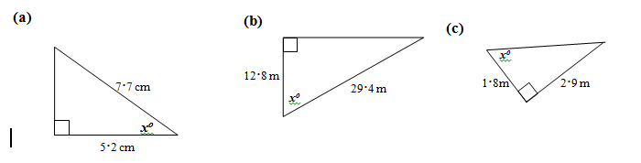

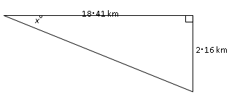

**21**. An aircraft making a steady descent decreases height by 2·16 km in 18·41 km.

What is the angle of descent, *x*o?

**22.** Find the area of each of the shapes shown below.

**(a)** 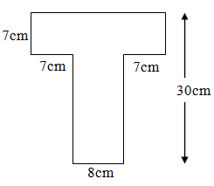

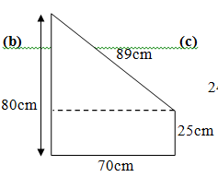

*x*o

18∙41 km

2∙16 km

**23**. (a) Draw coordinate axes on the grid below and plot the points A(–6, –8),

B(–4, 2) and C(6, 4).

(b) Plot a fourth point D to form a rhombus ABCD.

Join up the points to show the rhombus ABCD.

(c) Write down the coordinates of the point D

**24.** Enlarge these shapes using a scale factor of 1.5

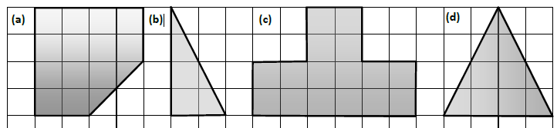

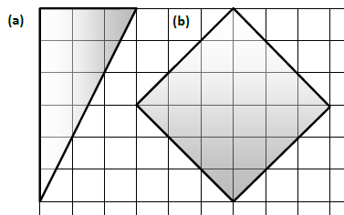**25.** Enlarge these shapes using a scale factor of 4/3

**26.** Margaret gets £25 a week for pocket money. She spends £14.65 on bus fares, £4.75 on sweets and she saves the rest.

**(a)** How much does she spend on bus fares and sweets?

**(b)** Margaret is saving up to buy a new bike which costs £187. How many weeks will it take her to save enough to buy her bike?

**27.** Stewart has £50 to buy some presents. He is going to buy a computer gamecosting £15.99, a book costing £12.75 and some perfume costing £22.40.

Does he have enough money to buy all of these?

**28.** Tommy is buying a new television. He cuts out a voucher from a newspaper which is offering a discount of £75 on it.

Tecom is selling the television for £640.

How much would Tommy actually pay using his voucher?

**29.** The local DIY store was charging £15.50 for a 2-litre can of paint. In a sale they were selling it for £12.95.

How much discount was this?

**30.**

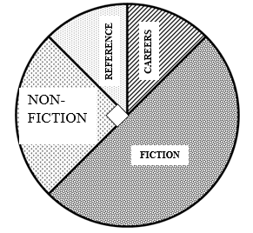

1200 books in the school library are classified in four categories.

**(a)** What fraction of the books are **(i)** fiction

**(ii)** non-fiction

**(iii)** reference

**(iv)** careers?

**(b)** How may non-fiction books are there ?

**(c)** How many careers books are there?

**31.**

A class of 30 pupils was asked about how they travelled to school.

**(a)** What fraction

**(i)** walked

**(ii)** came by bus

**(iii)** came by car

**(iv)** cycled?

**(b)** What was the least popular method of travel?

**(c)** How many came by bus?

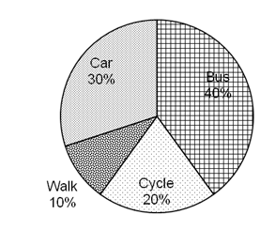

**32.** In each of these situations, decide which is the more likely to happen. Give a reason for you choice each time.

**(a) A:** choosing a red card from a pack of cards  **B:** throwing a multiple of 3 on a die

**(b) A:** choosing a double from a set of dominoes **B:** choosing a face card from a pack of cards

**(c) A:** throwing an even number on a die **B:** getting a head when a coin is tossed

**(d)** **A:** choosing an ace from a pack of cards **B:** getting a number more than 10 when throwing 2 dice

**(e)** **A:** getting a total of more than 7 when two dice are thrown **B:** getting ‘tails’ when a coin is tossed

**(f) A:** choosing a face card from a pack of cards **B:** choosing a club from a pack of cards

**33.** The height of a plant measured over five days is shown below.

**(a)** Plot the points and draw the best fitting straight line through them

**(b)** Use your line to estimate the height after 1½ days

34. The results of an experiment are shown in the table below.

**(a)** Plot the points and draw the best fitting straight line through them.

**(b)** Use your graph to estimate ***R*** when ***V*** is 0·8