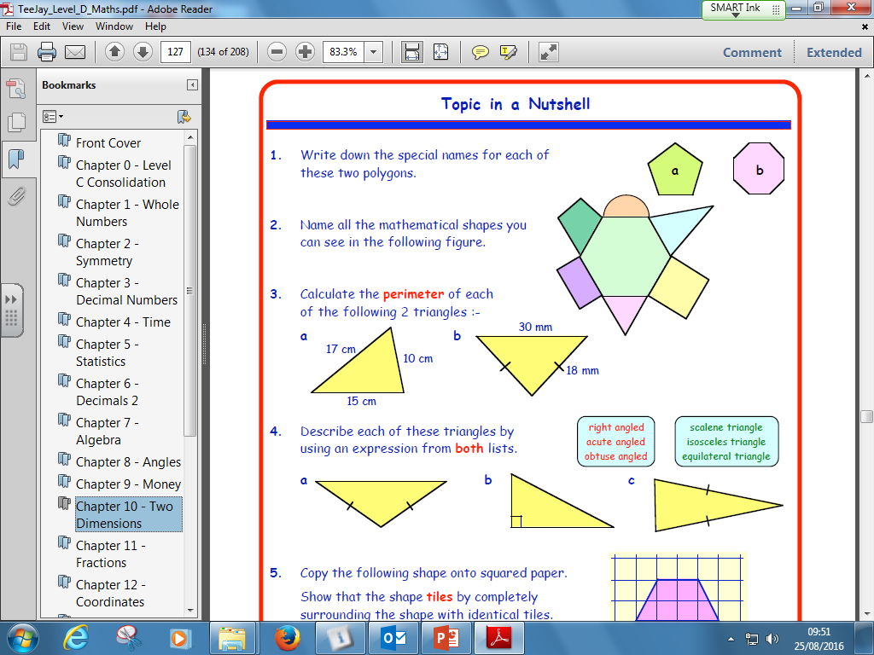S2 Homework

55

1. Use a calculator to find

a) 94% of 83 kg b) 6% of £428